**Name.Surajit Halder**

**PRN.24070521509**

**Sec.B2**

**Practice Basic JOINs**

1. Write a query to get all employees along with their department names.

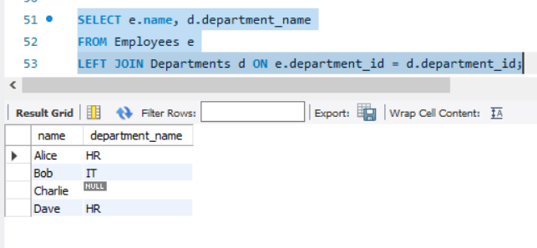

1. List the names of employees who do not belong to any department.

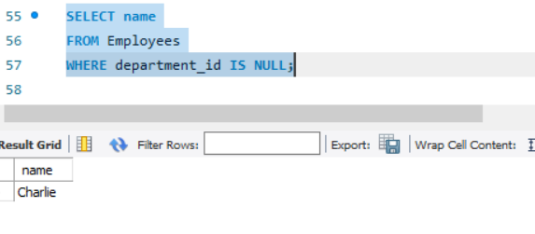

1. List all departments and the names of employees in them (if any).

INNER, LEFT, RIGHT, FULL JOINs

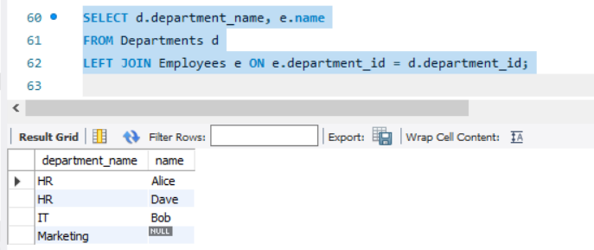

1. Use an INNER JOIN to find employees who are assigned to a department.

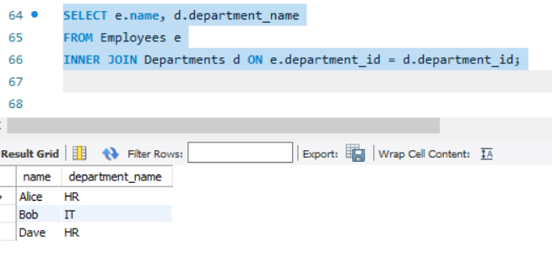

5. Use a LEFT JOIN to list all employees and their department names (even if department

is NULL).

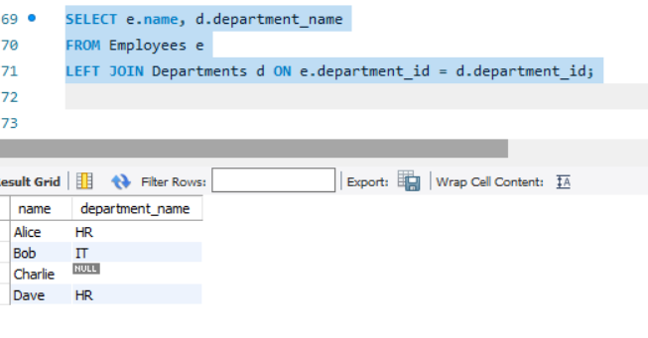

1. Use a RIGHT JOIN to list all departments and employees (if any).

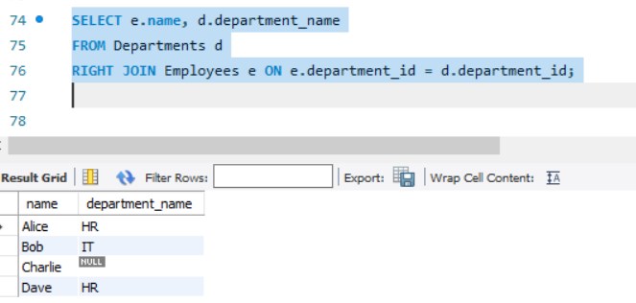

7. Use a FULL OUTER JOIN to show all employees and all departments, matching where

possible.

**JOIN with Conditions**

8. Write a query to list employees who earn more than any other employee in their

department.

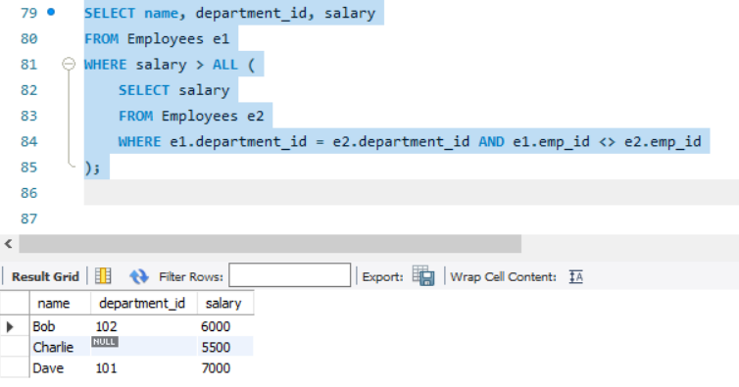

9. List all departments where no employees are assigned.

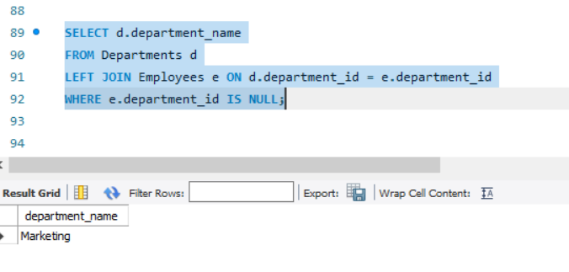

10. For each department, show the number of employees and the average salary.

